Source: http://ngm.nationalgeographic.com/2013/08/sugar/cohen-text

1. How is sugar today perceived differently than when it was first cultivated and what do you think is the major reason for this shift in mindset?

2. What role did religion play in the diffusion (spreading) of sugar throughout the world?

3. Explain why the European powers sought to expand their territories in the 1400s.

4. Identify what each of the arrows represents in this “Triangular Trade” diagram
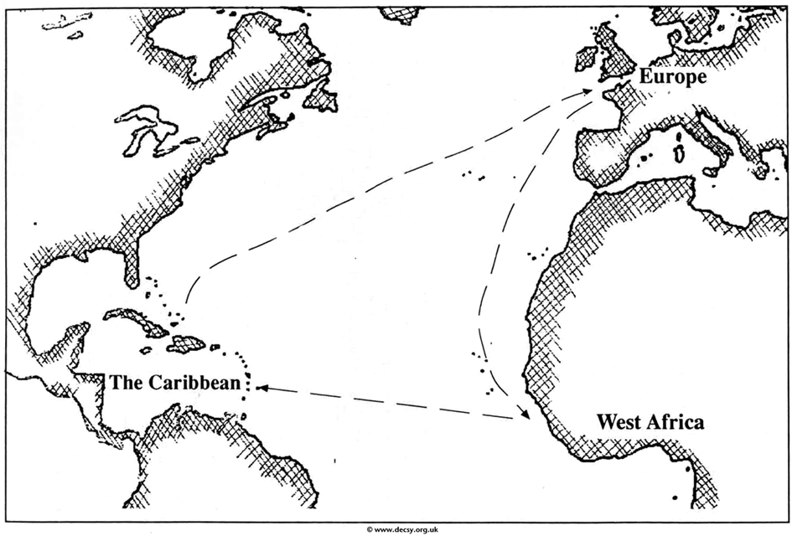

5. Explain the relationship between sugar and slavery.

6. What is some of the historical evidence linking sugar to illness?

***Skip “The Culprit”***

7. If sugar is so bad for us, then why do we like it?

